

This project is funded by
the European Union

Implementation of the New Computerized Transit System

Message exchange between
Traders and NTA_NCTSP5 v. 1.03
Reference doc: NCTS_EXT_v1_03

PROJECT REF: EuropeAid/139139/IH/SER/ME – Re-launch

Project Title | Implementation of the New Computerized Transit System
Contract Number | CFCU/MNE/074
Contracting Authority | Ministry of Finance, Directorate for Finance and Contracting of the EU Assistance Funds (CFCU)
CA Programme Manager | Ms Vesna Lučić
Beneficiary | Montenegrin Customs Administration
Beneficiary Contact person | Mr Danilo Podpara, Mrs Tatjana Vujisić
Contractor | Consortium - Solitea Business Solutions s.r.o., SafeNet d.o.o., CoreIT d.o.o
Contractor Contact person | Mr Tomáš Vinš, Project Director
Total budget of the action | EUR 2,350,000.00
Total duration of the action | 49 months
Team Leader | Mr Miroslav Bujna

Status of document
Submitted on | 9th May2022
Version | 1.03
Status | Draft
Status | For approval | X
Status | Approved

REVISION HISTORY
Ed. | Rev. | Date | Description | Action* | Page
1 | 00 | 30-09-2020 | First draft | I | All
1 | 01 | 30-10-2020 | Updated | I/R | 7,11,14,23,24,30,31,38,40
1 | 02 | 23-02-2021 | Updated | I/R | 15-17
1 | 03 | 09-05-2022 | Updated | I/R | 12,16,17,41
(*) Action: I=Insert R=Replace

Table of contents
Content
1. EXECUTIVE SUMMARY 4
2. INTRODUCTION 4
2.1. METHODOLOGY 5
2.2. SEQUENCE DIAGRAM 5
2.3. STRUCTURE OF THIS DOCUMENT 6
3. General description and definition 6
3.1. Actors 8
3.2. The list of electronic messages 10
3.2.1. Common Domain messages 11
3.2.2. External Domain messages 12
4. Communication between Holder of the transit procedure and Customs office of Departure 14
4.1. Customs office of Departure – transit basic scenario 14
4.2. Pre- lodged transit declaration 18
4.3. Amendment of e-TCD in standard and simplified procedure 21
4.3.1. Correction of the declaration data before acceptation 21
4.3.2. Amendment of accepted e-TCD in standard procedure 23
4.3.3. Amendment of accepted e-TCD in simplified procedure 25
4.4. Customs control decision 26
4.5. Release request 27
4.6. Guarantee not valid 30
4.7. Cancellation of the pre-lodged declaration prior to presentation of the goods or registered declaration before acceptation 31
4.8. Invalidation of the declaration 32
4.8.1. Invalidation before release of the goods in standard and simplified procedure 32
4.8.2. Invalidation after release of the goods 33
4.9. Solving of discrepancies at the Office of Departure 35
4.10. Start of enquiry procedure 36
4.11. Start of recovery procedure 37
4.12. Incident en route registration 37
5. Communication between Consignee and the Customs office if Destination 38
5.1. Standard procedure at the CO of Destination- basic scenario 38
5.2. Simplified procedure at the CO of Destination – basic scenario 39
5.2.1. Minor discrepancies during unloading 42
5.2.2. Major discrepancies 43
5.3. Customs control at the CO of Destination 44
5.4. Diversion rejected at the Office of Destination 46
6. General data Exchange 47
6.1. Functional error at the CO of Departure 47
6.2. Functional error at the CO of Destination 48
6.3. Technical XML error 48
7. Structure of messages 49
8. The list of annexes 49

Abbreviations
CO | Customs office
CTC | Convention on Common Transit procedure
e- TCD | Electronic Transit Customs Declaration
eAMS | External Authorisation Management System
Loi | List of Items
LRN | Local reference number
MRN | Master reference number
NCTS | New Computerized Transit System
NTA_NCTSP5 | National Transit Application for New Computerized Transit System
TAD | Transit accompanying document
TSAD | Transit/security accompanying document
UCC | Union Customs Code

- EXECUTIVE SUMMARY

This document describes messages and message exchanges between Trader’s SW and National Transit Application for New Computerized Transit System (NTA_NCTSP5) based on Functional specification for NTA NCTSP5 , as a result 1 of the EU funded project on “Implementation of the New Computerised Transit System (EuropeAid/139139/IH/SER/ME – Re-launch).
This document is part of the project delivery for Result 1, activity 1.14 – “Prepare draft documentation for publishing information and guidelines for business community” defined by Inception Report.

- INTRODUCTION
The successful development of the Montenegrin National Computerized Transit System in accordance to the EU NCTS specification for the common and Union transit procedures, shall be based on close communication with traders. Detailed specification of the NCTS functionalities for economic operators has vital importance for the proper design of all these functions at the site of economic operators and for non-problematic and efficient operation of the whole NCTS system.

The purpose of this document is to describe specification of the trader’s declaration system for NCTS functionalities and messages and message exchanges between the NCTS application used by economic operators and the Montenegrin NTA NCTSP5 application used by Montenegrin customs authorities.

This document contains the list of processes, which will be carried out directly by the economic operators and the Montenegrin customs officers according to the Montenegrin NTA NCTSP5 functional specification and Montenegrin internal provision for authorisation and simplification, which will be issued for economic operators with respect to the Montenegrin national legislation.
The document is supplemented in the Annex by a technical description of electronic message structures for the external domain with the rules, conditions and codes used to complete the messages.
  - METHODOLOGY

The description of the NCTS functionalities to be covered by the NTA_NCTSP5 application used by economic operators, is made in form of data scenarios using sequential diagrams.

The processes are documented using textual description. These processes must be supported by the software used by businesses to communicate with NTA_NCTSP5 application.
  - SEQUENCE DIAGRAM
A sequence diagram is a kind of interaction diagram that shows how processes operate with one to another and in which order. A sequence diagram shows object interactions arranged in time sequence. It depicts the objects and classes involved in the scenario and the sequence of messages exchanged between the objects needed to carry out the functionality of the scenario.
A sequence diagram shows, as parallel vertical lines, different processes or objects that live-act simultaneously, and, as horizontal arrows, the messages exchanged between them, in the order in which they occur. This allows the specification of simple runtime scenarios in a graphical manner according to the UML 2.0 notation.
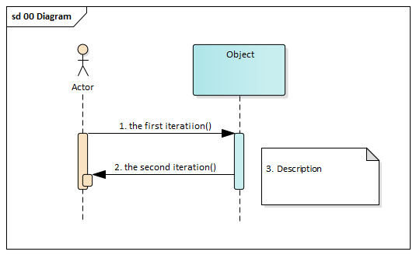
Figure 1 Example of time sequence diagram

  - STRUCTURE OF THIS DOCUMENT

The message exchange scenarios are grouped together according the role of Customs office, in which competences the communication is performed:

- Communication between the Holder of the procedure and Customs office of Departure
- Communication between the Consignee and Customs office of Destination
- General data exchanges
- Structure of data

Each message exchange scenario is defined as a sequence of messages, which are exchanged between a Trader (e.g. a Holder of the procedure or a Consignee) and Montenegrin Customs Administration in external (trades) domain.
Messages, which are exchanged between customs offices having different roles and exchanged within the national or common domain, are showed only in the case, when it is important for understanding of the e-TCD life cycle at the site of economic operator. The necessary national and common domain messages exchanged between customs offices are mentioned in message exchange scenarios, but their detail description is out of scope of this document.
- General description and definition

Local reference number (LRN)

LRN means the registration number issued by Holder’s of the procedure electronic system. Is used for identification of the transit declaration until MRN is allocated.

Master reference number (MRN)
MRN means the registration number allocated to a transit declaration by the competent customs authority using electronic data processing techniques
All transit operations, which will be used in NCTS application, will use the MRN format, which is prescribed by Common Transit Convention and UCC provisions. Montenegrin National Transit Application use MRN format which is given by Appendix III, Annex A4 of the CTC and updated Annex B UCC Implementing Act , Title I, D.E. 2/1

e.g. 20ME030000CE1FX7K9

Field | Content | Field type | Examples
1 | Last two digits of the year at which the declaration was accepted (YY) | Numeric 2 | 20
2 | Identifier of the country where the declaration is lodged (ISO alpha 2 country code) | Alphabetic 2 | ME
3 | Unique identifier for the acceptance given by the Office of Departure per year and country  5-10– Customs office od Departure reference number (030000)  11 - type of transit regime  (C- common transit, N – national transit)  12-16 - special number calculated as a hash code by serial number (E1FX7)  Remark:  This number will be calculated according to order number. More than 99999 numbers per year can be assigned. | Alphanumeric 12 | 030000CE1FX7
4 | Procedure identifier  J- transit declaration only  K – transit declaration and Exit summary declaration  L - transit declaration and Entry summary declaration  M - transit declaration and Exit summary declaration and Entry summary declaration | Alphabetic 1 | K
5 | Check digit | Alphanumeric 1 | 9

Field 1 and 2 as explained above
Field 3 has to be filled with
- the Customs Office Reference Number of the Office of Departure (n6) and
- the unique serial number in that year at the relevant customs office
Field 4 Procedure identifier
Field 5 has to be filled with a value that is a check digit for the fields 1 to 4 of the MRN. Check digit is calculated according the document “Check Character Algorithm for the MRN and GRN” published by TAXUD. This field allows the detection of an error when capturing the first three fields of the MRN.
In case of MRN issued during fallback procedure, check digit will be replaced by letter “F”.

The Transit accompanying document (TAD) or Transit/security accompanying document (TSAD) is document printed by the computerised system to accompany the goods and based on the data and the entry or exit summary declaration of the electronic transit declaration. This document is used in NCTS P5 on voluntary basis.

The Fall-back procedure is the procedure based on the use of paper document (usually in a form of Single Administrative Document (SAD)) established to allow the lodging, the control of the transit declaration and the following of the transit operation when it is not possible to implement the standard procedure by electronic means.

Standard procedure - a process based on the standard processing of a transit declaration with the presentation of goods at a designated place, most often at the customs office.

Simplified procedure - procedure based on automated process requiring authorisation for simplified procedure at Departure or Destination.

Authorisation for electronic communication with the Customs Offices of Departure is the authorisation issued by the competent Montenegrin customs authority specifying the rules and conditions of Electronic Data Interchange (EDI) between a computer system used by economic operator and a computer system used by the Montenegrin customs authorities, which is necessary for lodging the e-TCD and for exchanging other electronic messages.

Authorisation for electronic communication with Customs Offices of Destination is the authorisation issued by the competent Montenegrin customs authority specifying the rules and conditions of Electronic Data Interchange (EDI) between a computer system used by economic operator and a computer system used by the Montenegrin customs authorities, which is necessary for lodging the electronic notification of consignment’s arrival and for exchanging these messages.

Authorisation for usage of the simplified procedure of the Authorised Consignor is the authorisation, which enable a holder of this authorisation to place the goods into the transit regime itself without necessity to present the goods physically at the CO of Departure. The holder of this authorisation can place the goods into transit regime in days and hours specified in this authorisation, even 24 hours/day and 7days per week.

Authorisation for usage of the simplified procedure of the Authorised Consignee is the authorisation, which enable a holder of this authorisation to receive at his premises or at any other specified place goods placed for the transit regime without presenting them and the Transit Accompanying Document or the Transit/security Accompanying Document at the CO of Destination.
  - Actors
This chapter contains list of users of the Montenegrin New Computerized Transit System (NCTS) either from the MCA or from the business community and the list of functionalities used by these users. The technical users, like administrators, are not listed here.
Actor | Description
Customs officer at the CO of departure | The customs office where the customs declaration placing goods under a transit procedure is lodged. This customs office controls the goods, allows (or not) the goods to be released for transit, initiates the enquiry procedure if necessary and discharges the transit operation or initiates the recovery procedure.  The main functionality:  - Register new declaration  - Accept new declaration  - Amend the data of transit procedure  - Decide to control  - Register control results  - Release the goods for transit procedure and print Transit Accompany Document  - Cancel declaration based on customs decision  - Revoke declaration based on trade’s decision  - Start the enquiry procedure to Holder of the procedure or CO  - Register enquiry result information received from CO or from Holder of the procedure  - Cancel enquiry to CO  - Identify CO of Recovery  - Start the procedure for recovery of customs debt at CO of Recovery  - Issue the authorization for recovery customs debt  - Confirm finishing of recovery  - Solve discrepancies
Customs officer at the CO of destination | The customs office where the goods placed under a transit procedure are presented in order to end the procedure.  - Register consignment arrival at the CO of Destination  - Register presented TAD (Transit Accompany Document) manually in fall-back procedure  - Decide to discharge the transit procedure  - End transit procedure  - Decide to control  - Control of the goods and/or supporting documents  - Register control results  - Decide to control based on unloading information sent by authorised consignee  - Register result of control in fall-back mode  - Confirm the discrepancies result sent from CO of Departure  - Require movement information
Requested Competent Authority of Enquiry | The Customs Authority either at Departure or Destination, which is competent to handle the enquiry activities of a movement.  - Carry out enquiry  - Require movement information
Requested Competent Authority of Recovery | The Customs Authority either at Departure or Destination or Other Country, which is competent to handle the recovery activities of a movement.  - Carry out recovery  - Require movement information
Holder of the Transit procedure | The person who lodges the customs declaration, or on whose behalf that declaration is lodged.  - Submit new declaration electronically  - Submit an amendment of the registered transit declaration  - Cancel declaration before release  - Provide enquiry information  - Present explanation for discrepancies found at CO of Destination
Consignee /Authorised consignee | The Trader who presents the consignment to the final destination where the transit movement ends.  - Send information about transit consignment arrives at destination (Consignee or Authorised Consignee)  - Present transit at the CO of destination  - Send unloading information  - Return documents

  - The list of electronic messages
The following figure Figure 2 Overview of Information Exchange and roles regarding the NCTS shows in general the message data exchange of the actual NCTS transit system. This figure shows the overview of different parties and messages. The usage of the messages, which are exchanged in external domain (prefix “ME_” instead of “IE”), will be described in this document. Messages related to Common domain (prefix “CD_” instead of “IE” ), are exchanged between customs offices and are not described in this document.

Figure 2 Overview of Information exchange within NCTS
    - Common Domain messages

The messages for common domain used with prefix “CD”
These messages are exchanged between customs offices within the Common Domain in these roles the roles: Customs Office of Departure (OoDep) Customs Office of Destination (OoDes) Customs Office Tranzit (OoTra), Customs Office of Exit for Transit (OoExTra)

Code | Description |  | Sender | Recipient
CD001C | Anticipated arrival record |  | OoDep | OoDes
CD002C | Anticipated arrival record request |  | OoDes | OoDep
CD003C | Anticipated arrival record response |  | OoDep | OoDes
CD006C | Arrival advice |  | OoDes | OoDep
CD010C | Invalidation notification |  | OoDep | OoDes/OoTra/OoExtrTra
CD018C | Destination control result |  | OoDes | OoDep
CD024C | Forwarded arrival advice |  | OoDep | OoDes/OoTra/OoExtrTra
CD027C | Movement query |  | Any office | OoDep
CD038C | Response to movement query |  | OoDep | Any office
CD049C | Discrepancies solved notification |  | OoDep | OoDes
CD050C | Anticipated transit record |  | OoDep | OoTra
CD094C | Status request |  | OoDep | OoDes
CD095C | Status response |  | OoDes | OoDep
CD114C | Anticipated transit record request |  | OoTra | OoDep
CD115C | Anticipated transit record response |  | OoDep | OoTra
CD118C | Notification crossing border |  | OoTra | OoDep
CD160C | Anticipated exit for transit record |  | OoDep | OoExtTra
CD164C | Anticipated exit for transit record request |  | OoExtTra | OoDep
CD168C | Anticipated exit for transit record response |  | OoDep | OoExtTra
CD180C | Incident notification |  | OoIncReg | OoDep
CD181C | Forwarded incident notification to CD |  | OoDep | OoDes/OoTra/OoExtrTra

    - External Domain messages
These messages are exchanged within the External Domain between the roles: Customs Office of Departure and Holder of the procedure or Customs office of Destination and Consignee (Authorised consignee).

Code | Description |  | Sender | Recipient
ME004C | Amendment acceptance |  | OoDep | Holder
ME007C | Arrival notification |  | Consignee | OoDes
ME009C | Invalidation / cancellation decision |  | OoDep | Holder
ME010C | Additional Information Request |  | OoDep | Holder
ME013C | Declaration amendment |  | Holder | OoDep
ME014C | Declaration invalidation request |  | Holder | OoDep
ME015C | Declaration data |  | Holder | OoDep
ME019C | Discrepancies notification |  | OoDep | Holder
ME025C | Goods release notification |  | OoDes | Consignee
ME028C | MRN allocated/Declaration acceptance |  | OoDep | Holder
ME029C | Release for transit |  | OoDep | Holder
ME035C | Recovery notification |  | OoDep | Holder
ME043C | Unloading permission |  | OoDes | Consignee
ME044C | Unloading remarks |  | Consignee | OoDes
ME045C | Write-off notification |  | OoDep | Holder
ME051C | No release for transit |  | OoDep | Holder
ME054C | Request for release |  | Holder | OoDep
ME055C | Guarantee not valid |  | OoDep | Holder
ME056C | Rejection from Office of Departure |  | OoDep | Holder
ME057C | Rejection from Office of Destination |  | OoDes | Consignee
ME060C | Control decision notification |  | OoDep | Holder
ME140C | Request on non-arrived movement |  | OoDep | Holder
ME141C | Information about non-arrived movement |  | Holder | OoDep
ME170C | Presentation notification for the pre-lodged  declaration |  | Holder | OoDep
ME182C | Forwarded incident notification to ED |  | OoDep | Holder
ME917C | XML NACK (XML error) |  | OoDep/OoDes | Holder/ Consignee
ME928C | Positive acknowledge – TCD registration |  | OoDep | Holder

Detailed description of these messages and allowed communication scenarios are described in following chapters.
Detail message structure is described in form of XSD. For easier understanding the HTML documentation is prepared too. The XSD and HTML message documentation are distributed as external attachment of this document.

Authorisation for electronic communication with Offices of Departure and Offices of Destination, issued by a competent customs office and registered in the eAMS, is necessary for exchange of these messages. Authorisation for electronic communication with Offices of Departure and Offices of Destination shall content the list of exchanged messages with their purpose and sequence, relevant rules and conditions, which are used for clarification of data groups and data elements contained in exchanged messages.

- Communication between Holder of the transit procedure and Customs office of Departure
This chapter describes the message exchange scenarios between Office of Departure and the Holder of the procedure.
  - Customs office of Departure – transit basic scenario
Standard procedure
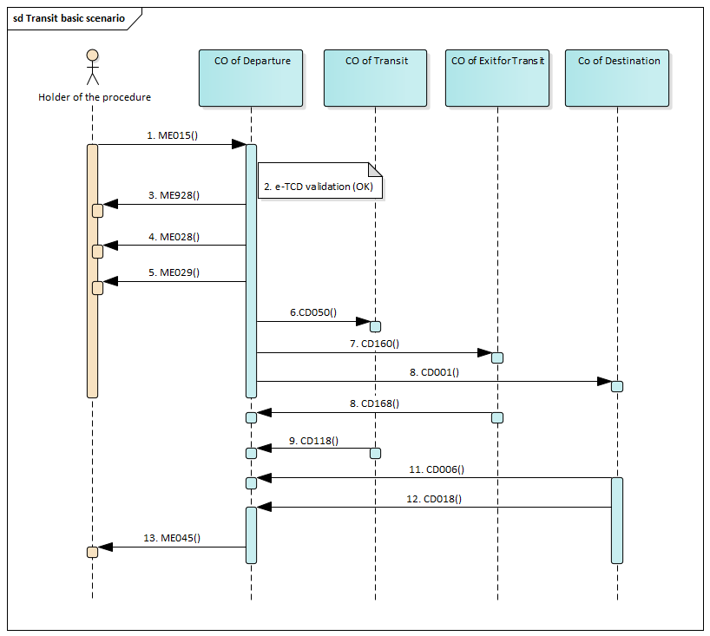
Figure 3 NCTS - transit basic scenario – standard procedure

The figure 3 NCTS - transit basic scenario describes the most frequent data exchange between the Holder of the procedure (the economic operator), who use the standard procedure and CO of Departure.

- Holder of the procedure lodges the e-TCD via the message ME015 at declared CO of Departure.
- The NCTS validates the lodged e-TCD (message ME015). The NTA_NCTSP5 checks:
  - validity of the format of the message against the XSD definition,
  - validity of Authorisation for electronic communication in transit procedure with Montenegrin CO of Departure,

2.3. the data content of the e-TCD and fulfillment of all rules and condition, which are given by the Rulebook and Authorisation for electronic communication in transit procedure with Montenegrin CO of Departure.

- After successful checks the NTA_NCTSP5 will reply to Holder of the procedure by the message ME928 identified by LRN which was used in originally declaration (ME015). TCD was successfully registered.
Holder of the transit procedure (or his Representative) presents declared goods and all documents accompanying transit declaration (e.g. transport documents, invoices, certificates, …) at the CO of Departure using the LRN as a main transit identifier for e-TCD.
Competent Customs Officer at the CO of Departure checks registered declaration, declared goods and accompanying documents and he decides to accept e-TCD.

- The NTA_NCTSP5 sends to Holder of the transit procedure (or his Representative) the message ME028 to inform him, that the e-TCD was accepted and MRN was allocated.

Competent Customs officer at the CO of Departure can decide to release the goods into the transit regime without physical control of declared goods. The Officer:
- Set time limit for delivery of the goods to CO of Destination
- Seals the consignment (if is possible or needed)
- On request, prints the TAD or TSAD and List of Items (LoI), when more than one item of goods are declared), and hand it over to person who present the goods (Holder of the procedure or his representative or driver).

- The NTA_NCTSP5 sends to Holder of the transit procedure (or his Representative) the message ME029 to inform him, that the goods were released to the transit regime and that the used transit guarantee was allocated for this movement (which is identify by the MRN).

- The NTA_NCTSP5 at the CO of Departure informs all declared CO’s of Transit about the movement (i.e. notification with MRN is sent).

- The NTA_NCTSP5 at the CO of Departure informs all declared CO’s of Transit about the movement (i.e. notification with MRN is sent).

- The NTA_NCTSP5 at the CO of Departure informs declared CO of Destination about the movement (i.e. notification with MRN is sent).

- In case of safety & security movement the NTA_NCTSP5 at each actual CO of Exit for Transit informs the CO of Departure, that the movement (MRN) left the Montenegrin customs territory

- In case of common transit procedure, the NTA_NCTSP5 at each actual CO of Transit informs the CO of Departure, that the movement (MRN) cross the frontier.

- The NTA_NCTSP5 at actual CO of Destination informs the CO of Departure, that the movement (MRN) was presented at the CO of Destination. If the comprehensive guarantee or the guarantee waiver is used, the amount of the comprehensive guarantee, which was allocated to the movement, is credited back for next usage at this moment.

- The NTA_NCTSP5 at actual CO of Destination informs the CO of Departure, that control results are successful.

- The NTA_NCTSP5 sends to Holder of the transit procedure (or his Representative) the message ME045 to inform him, that goods were presented without discrepancies at the CO of Destination and the transit regime was discharged at the CO of Departure At this moment, used amount of transit guarantee is finally released.
Simplified procedure
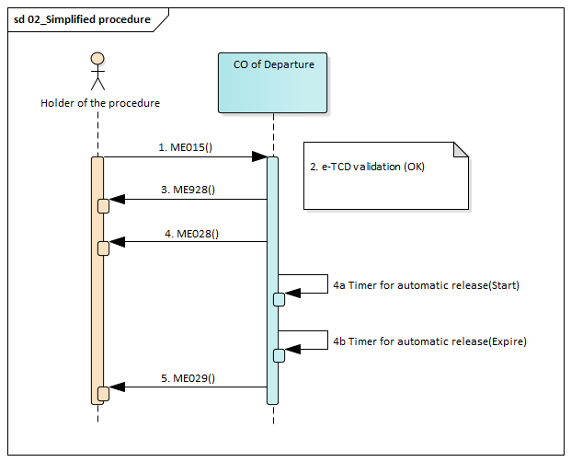
Figure 4 NCTS simplified procedure at CO of Departure

Nevertheless, the business and processes at the site of authorised consignor and at the customs site is quite different, the sequence of the messages in this data exchange scenario is very similar (without step 3 – Registration - ME928 message). Using of simplified procedure is depend on certification for Authorised consignor for common transit or for national transit at the relevant customs office.

- Authorised consignor lodges the e-TCD via the message ME015 at declared CO of Departure. Goods have to lodged and sealed by special seal accordance to authorization.
- The NCTS validates the lodged e-TCD (message ME015). The NTA_NCTSP5 checks:
  - validity of the format of the message against the XSD definition,
  - validity of Authorisation for electronic communication in transit procedure with Montenegrin Customs Offices of Departure,
  - validity of Authorisation of the simplified procedure of the Authorised Consignor (Authorisation type = “C521” and Authorisation reference number is used)

Filling of ME015 message in simplified procedure at CO Departure – Authorised consignor
Authorised consignor
  - AUTHORISATION/Decision reference number is used with “Authorisation type = C521”
e.g. MEACRME030000-2020-000019
  - TRANSIT OPERATION.Limit date

  - CONSIGMENT/LOCATION OF GOODS data group will be used
    - Type of location – B – Authorized place
    - Qualifier of identification – Y - Authorisation number
    - Authorisation number - real reference number of authorization location of goods - e.g. MEAPLME030000-2020-000019
    - Additional identifier – can be used for identification of location where there are several locations associated with one authorization - e.g. 0001

  - the data content of the e-TCD and fulfillment of all rules and condition, which are given by the Rulebook and Authorisation for electronic communication in transit procedure with Montenegrin Customs Offices of Departure.

- After successful checks the NTA_NCTSP5 will reply to Holder of the procedure by the message ME928 identified by LRN which was used in originally declaration (ME015). TCD was successfully registered.

- Due to the fact that the goods and all accompanying documents are processed by Authorised Consignor according to his authorisation, the NTA_NCTSP5 can immediately accepts the e-TCD (allocate MRN). The message ME028 is sent immediately after ME928.

- The NTA_NCTSP5 sends to Authorised Consignor the message ME028 to inform him, that the e-TCD was automatically accepted and MRN was allocated.
- The timer for automated release to transit regime, which is given in the Authorised consignor authorisation, is started.
- In the case, when no customs controls are ordered by the CO of Departure, the goods are released to the transit regime without any delay, when the timer for automated release expires. This time limit is set up individually for each Authorised Consignor in his authorisation.

- The NTA_NCTSP5 sends to Authorised Consignor the message ME029 to inform him, that the goods were released to the transit regime and that the declared transit guarantee was allocated for this movement.
When Authorised Consignor receives the message ME029 he:
- Can to print on carrier’s request Transit Accompanying Document (TAD od TSAD) (and List of Items (LoI), when more than one item of goods are declared,
- Gives printed Transit Accompanying Document (TAD or TSAD ) (and List of Items (LoI), when more than one item of goods are declared) and all transit/transport documents to the carrier (e.g. driver).
The movement of consignment (MRN) is ready to start.
This scenario continues according description given in chapter 4.1 NCTS transit basic scenario, starting in point 6 in the chapter 4.1.
  - Declaration not accepted

The process starts by point 1-3 from 4.1.
- Customs officer at the OoDep decided to not accept the declaration. Reasons are described in the decision message ME009.
- The NTA_NCTSP5 sends to Holder of the transit procedure (or his Representative) the message ME009 to inform him, that MRN was allocated , however the e-TCD was not accepted.

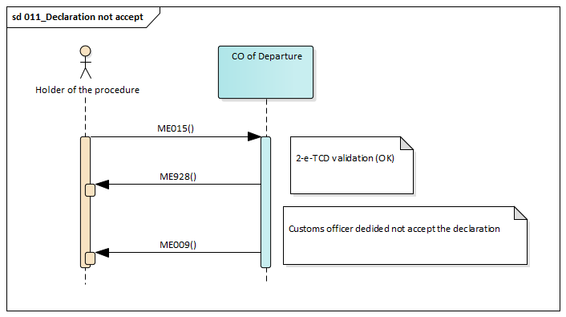
Figure 4_1 NCTS – Declaration not accepted

  - Pre- lodged transit declaration
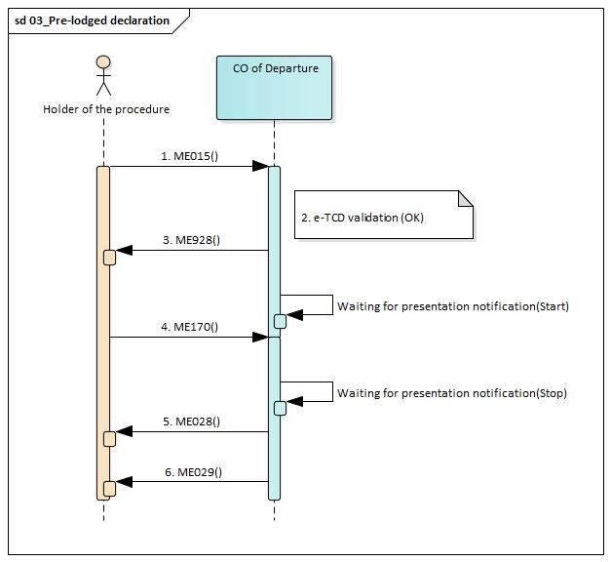
Figure 4 NCTS – Pre-lodged transit declaration
According to art. 29a App. I CTC (art. 171 UCC) the customs declaration with “Additional Declaration Type” = “D” in ME015 can be lodged for the purpose of risk analysis thirty (30) days prior to the presentation of the goods to the Office of Departure (‘Additional Declaration Type = “D” in ME015). If it is valid, the ME928 message is sent to the Holder of the Transit Procedure.

- Holder of the procedure lodges the e-TCD via the message ME015 at declared CO of Departure.
- The NCTS validates the lodged e-TCD (message ME015). The NTA_NCTSP5 checks:
  - validity of the format of the message against the XSD definition,
  - validity of Authorisation for electronic communication in transit procedure with Montenegrin Customs Offices of Departure,
  - the data content of the e-TCD and fulfillment of all rules and condition, which are given by the Rulebook and Authorisation for electronic communication in transit procedure with Montenegrin Customs Offices of Departure.

- After successful checks the NTA_NCTSP5 will reply to Holder of the procedure by the message ME928 identified by LRN which was used in originally declaration (ME015). TCD was successfully registered.

- Goods presented within time limit (30 days since registration):

- Within prescribed time limit the Holder of the transit procedure (or his Representative) submits the ‘Transit Presentation Notification’ - ME170 to the CO of Departure and presents declared goods and all documents accompanying transit declaration (e.g. transport documents, invoices, certificates, …) at the CO of Departure using the LRN as a main transit identifier for e-TCD. Competent Customs Officer at the CO of Departure checks registered declaration, declared goods and accompanying documents and he decides to accept e-TCD.

- The NTA_NCTSP5 sends to Holder of the transit procedure (or his Representative) the message ME028 to inform him, that the e-TCD was accepted and MRN was allocated.

- The NTA_NCTSP5 sends to Holder of the transit procedure (or his Representative) the message ME029 to inform him, that the goods were released to the transit regime and that the used transit guarantee was allocated for this movement (which is identify by the MRN).

- No goods are presented by when timer expires:

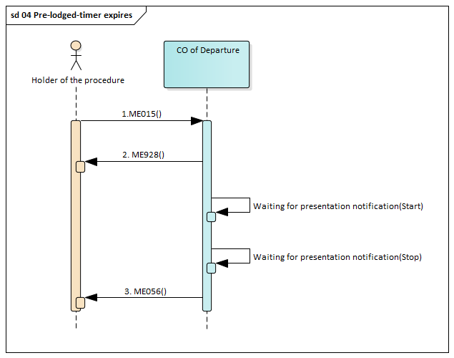
Figure 5 Pre-lodged transit declaration – expiration of the timer

- Holder of the procedure lodges the e-TCD via the message ME015 at declared CO of Departure.
- Within prescribed time limit no goods are presented by when this timer expires.
- The NTA_NCTSP5 rejects the pre-lodged transit declaration sends and the ‘Declaration Rejected’ ME056 message is sent to the Holder of the procedure.

  - Amendment of e-TCD in standard and simplified procedure

Amendments of a transit declaration enable changes to the declaration data until the goods can be released for transit.
When the ‘Declaration Amendment’ (ME013) is sent to the CO of Departure by the Holder of the Transit Procedure, the Office of Departure always needs to decide whether to:
  - Accept it [‘Amendment Acceptance’ (ME004)], or
  - Reject it [‘Rejection from Office of Departure’ (ME056)]
No amendment requests by the Holder of the Transit Procedure are allowed:
  - Before the declaration is accepted by customs, (data can be corrected by Holder of the procedure sending message ME013 at many times before acceptation but in legal point of view is not „amendment” yet) and
  - Then how the Office of Departure decided about control of goods (ME060 already sent),
  - After the goods are released for transit
    - Correction of the declaration data before acceptation

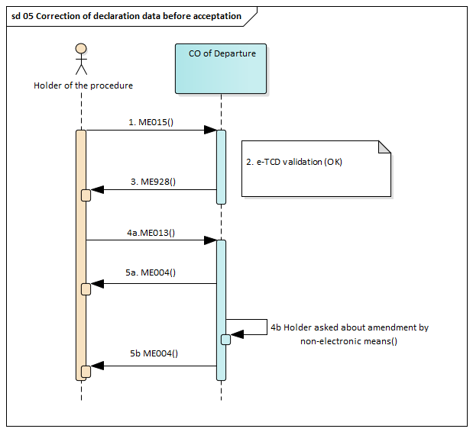
Figure 6 Correction of the declaration data before acceptation

Holder of the procedure needs to amend some value in the e-TCD data (registered e-TCD) from any reason. The amendment of the registered e-TCD could be done before the CO of Departure accepts the e-TCD in the standard procedure.

For correction of the TCD data before acceptation (only registered), the Holder of the procedure can amend automatically (by ME013 message), however following Data Groups and Data items cannot be amended:
      - HOLDER OF THE TRANSIT PROCEDURE
      - REPRESENTATIVE
      - CUSTOMS OFFICE OF DEPARTURE
And following Data Items
      - TRANSIT OPERATION/Additional declaration type
      - TRANSIT OPERATION/Declaration type
      - TRANSIT OPERATION/LRN

- Holder of the procedure lodges the e-TCD via the message ME015 at declared CO of Departure.
- The NTA_NCTSP5 validates the lodged e-TCD (message ME015). The NTA_NCTSP5 checks:
  - validity of the format of the message against the XSD definition,
  - validity of Authorisation for electronic communication in transit procedure with Montenegrin Customs Offices of Departure,
  - the data content of the e-TCD and fulfillment of all rules and condition, which are given by the Rulebook and Authorisation for electronic communication in transit procedure with Montenegrin Customs Offices of Departure.
- After successful checks the NTA_NCTSP5 will reply to Holder of the procedure by the message ME928 identified by LRN which was used in originally declaration (ME015). TCD was successfully registered.

- Amend the e-TCD’s data electronically using system NTA_NCTSP5:

- Holder of the transit procedure repairs data of the registered e-TCD in his system and sends corrected e-TCD to the CO of Departure via message ME013.

- The NTA_NCTSP5 confirms the amendment of the e-TCD via message ME004, which is sent to the Holder of the procedure. When the amendment is confirmed by the message ME004, Holder of the transit procedure can presents declared goods and all documents accompanying transit declaration at the CO of Departure using the assigned MRN as a main transit identifier for e-TCD.

- Amend the e-TCD’s data personally using a paper based (or oral) request submitted at the CO of Departure:

- Holder of the transit procedure presents declared goods together with a written (oral) amendment request and together with all documents accompanying transit declaration at the competent Customs officer at the CO of Departure.
- Competent Customs officer at the CO of Departure checks the declared goods and documents accompanying e-TCD and decides to accept the amendment request and accept the e-TCD (MRN).

    - Amendment of accepted e-TCD in standard procedure
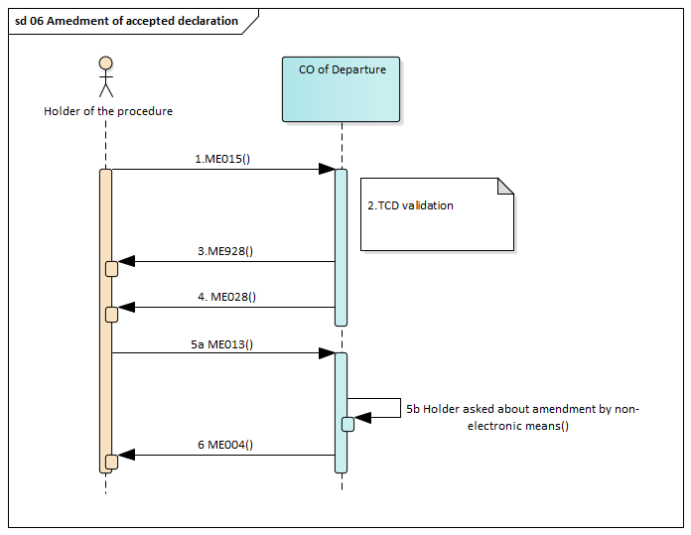
Figure 7 Amendment of declaration data after acceptation in the standard procedure

The process starts by point 1-3 from 4.3.1.

- The NTA_NCTSP5 sends to Holder of the transit procedure (or his Representative) the message ME028 to inform him, that the e-TCD was accepted and MRN was allocated.

- This scenario is used in standard procedure, when some incorrect information is discovered after acceptance of the e-TCD (MRN) and before release of the goods to transit regime at the CO of Departure.
Holder of the procedure needs to amend some value in the e-TCD data (accepted e-TCD) from any reason. The amendment of the accepted e-TCD could be done before the CO of Departure release the e-TCD in the procedure.

- Amend the e-TCD’s data electronically using system NTA_NCTSP5:

For amending the “Accepted” TCD data, the Holder of the procedure can amend in the same way automatically (ME013 message), however following Data Groups and Data items cannot be amended:
      - HOLDER OF THE TRANSIT PROCEDURE
      - REPRESENTATIVE
      - CUSTOMS OFFICE OF DEPARTURE
And following Data Items
      - TRANSIT OPERATION/Additional declaration type
      - TRANSIT OPERATION/Declaration type
      - TRANSIT OPERATION/MRN
      - TRANSIT OPERATION/LRN
      - CONSIGNMENT-HOUSE CONSIGNMENT-CONSIGNMENT ITEM-COMMODITY-COMMODITY CODE.Harmonised system sub-heading code>¹
      - TRANSIT OPERATION/Security
¹ In case of amendment by customs officer is allowed for amendment

- Amend the e-TCD’s data personally using a paper based (or oral) request submitted at the CO of Departure:

Holder of the transit procedure presents declared goods together with a written (oral) amendment request and together with all documents accompanying transit declaration at the competent Customs officer at the CO of Departure. Competent Customs officer at the CO of Departure checks the declared goods and documents accompanying e-TCD and decides to accept the amendment request and accept the e-TCD (MRN).

- The NTA_NCTSP5 confirms the amendment of the e-TCD via message ME004, which is sent to the Holder of the procedure. When the amendment is confirmed by the message ME004, Holder of the transit procedure can presents declared goods and all documents accompanying transit declaration at the CO of Departure using the assigned MRN as a main transit identifier for e-TCD.
Note!
For amending e-TCD in the state “Guarantee under amendment” the Holder of the procedure can amend by sending of ME013 message (Amendment type flag = 1) only data group “Guarantee”. See point 4.6.

    - Amendment of accepted e-TCD in simplified procedure
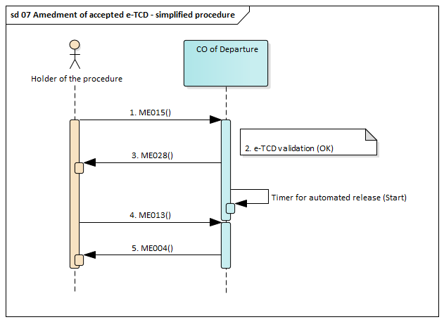
Figure 8 Amendment of declaration data after acceptation in the standard procedure
When simplified procedure is used, the Authorised Consignor could amend the accepted e-TCD, only if no customs control was ordered and only before release declared goods for transit procedure (during the timer between acceptance and automated release).
This scenario starts according to the description given in chapter 4.1 NCTS transit basic scenario, simplified procedure, starting in point 1 and ending by point 3. The amendment is initiated by Authorised Consignor, when some incorrect information have been lodged in the e-TCD.
Authorised Consignor must find out the mistake before the timer for release of goods for transit procedure expires. He amends the data of the e-TCD in his system and he sends the message ME0013 to the CO of Departure.

- Authorised Consignor amends the data of the accepted e-TCD and sends correct values to the
CO of Departure via the message ME013

- The NTA_NCTSP5 confirms via message ME004 the acceptance of lodged amendment of the
registered e-TCD to the Authorised Consignor.

In the case, when customs control was ordered (ME060 sent) or the goods with this e-TCD were released for transit procedure (ME029 sent) before the request for amendment was received, the Authorised Consignor is informed by the error message ME056 that the request for amendment was refused.
In the case, when the amendment was refused, and the wrongly declared goods were released to transit regime, the Authorised Consignor must personally contact the CO of Departure to solve this case according to given instructions.
In the case, when request for amendment was successfully registered, this scenario can continue according description given in chapter 4.1 NCTS transit basic scenario, simplified procedure, starting in point 5.
  - Customs control decision

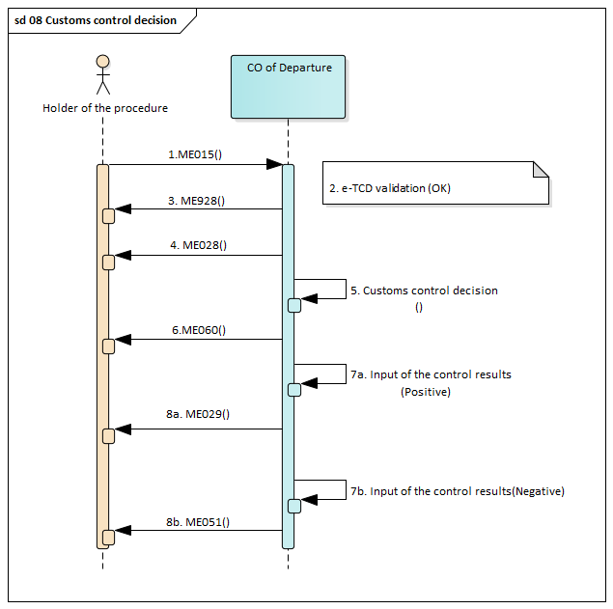
Figure 9 Customs control decision (standard and simplified procedure)

This scenario is commonly used for standard and simplified procedure in transit regime. Scenario starts according to the description given in chapter 4.1 NCTS transit basic scenario, with point 1 and ending by point 3.

Standard procedure:

  - The NTA_NCTSP5 sends to the Holder of the procedure the message ME028 to inform him, that the e-TCD was accepted.
  - Competent Customs officer at the CO of Departure decides to do the customs control, or the customs control is ordered by the customs risk analysis module.
  - The NTA_NCTSP5 sends to the Holder of the procedure the message ME060 to inform him, that the customs control of the goods and document was ordered. The Holder of the procedure is informed, and he can participate during the customs control.

- Customs control is performed, and no serious discrepancies are found.

  - The competent Customs officer inputs the positive results of control into the customs system and a customs officer decides to release goods into the transit regime. Customs officer seals the consignment (e.g. the loading compartment of mean of transport), prints and stamps the Transit Accompanying Document (TAD) and forwards TAD (and LoI, if is used) to the Holder of the procedure (or his Representative).

  - The NTA_NCTSP5 sends to the Holder of the procedure the message ME029 to inform him, that the goods were released to the transit regime and that the used transit guarantee was allocated to this movement.

- Customs control is performed, and serious discrepancies are found.

  - The competent Customs officer input the negative results of control into the customs system and a customs officer decides to not release goods into the transit regime.

  - The NTA_NCTSP5 sends to the Holder of the procedure the message ME051 to inform him, that the goods were not released to the transit regime.

The “non-release decision” is the final state of the e-TCD life-cycle at this moment.

Note:
In case of pre-lodged declarations can be sent the message ME060 before presentation of the goods when Holder of the procedure is a holder of AEO certificate. This message indicates potential control of the goods at the time of presentation. Message can contains request for additional information or documents (TRANSIT OPERATION/Notification type = 1”). In this case according to instructions (TRANSIT OPERATION/Control notification text ”) Holder of the procedure has to send information or documents on contacts described in “Customs Office of Departure/Contact persons”.
Customs authorities provided risk analyses at the CO of Departure can anytime ask to Holder of the procedure about additional information or documents. In this case according to instructions (TRANSIT OPERATION/Control notification text ”) Holder of the procedure has to send information or documents on contacts described in “Customs Office of Departure/Contact persons”.

  - Release request
This scenario starts according to the description given in chapter 4.5 Customs control decision, with point 1 and ending by point 6.

- When minor discrepancies are detected during the control of the goods and/or supporting documents, the Holder of Transit procedure is notified about minor discrepancies by Inspection protocol, because Holder of the procedure should be present at the physical control. A timer “Declaration awaiting release request” is started to protect a non-release request of the goods coming from the Holder of Transit procedure. The Customs Officer records the controlled goods and revises the declaration data.

- When Holder of the transit procedure is present and agreed with changes in the declaration proposed by customs officer, declaration after amendment can be released (ME029 sent to Holder).

- When Holder of the procedure is not present at the Office of Departure he has to provide an advice (positive or negative) within a timer limit by means of the ‘Request of Release’ (message ME054) (i.e. flag ‘Release requested’ is set to either ‘0-No’ or ‘1-Yes’);

- In case of positive reaction (Release requested’ is set to either ‘1-Yes’), the TCD is automatically processed.

- In case when Holder of the Transit Procedure gives opposition to these revisions (Release requested’ is set to either ‘0-No’), the movement’s state is set to “Idle” and the Office of Departure decides whether to release or not the transit movement. If the decision is that the transit movement can be released, then the guarantee registration takes place. In case the timer expires, the movement is not released for transit (ME051 is sent).
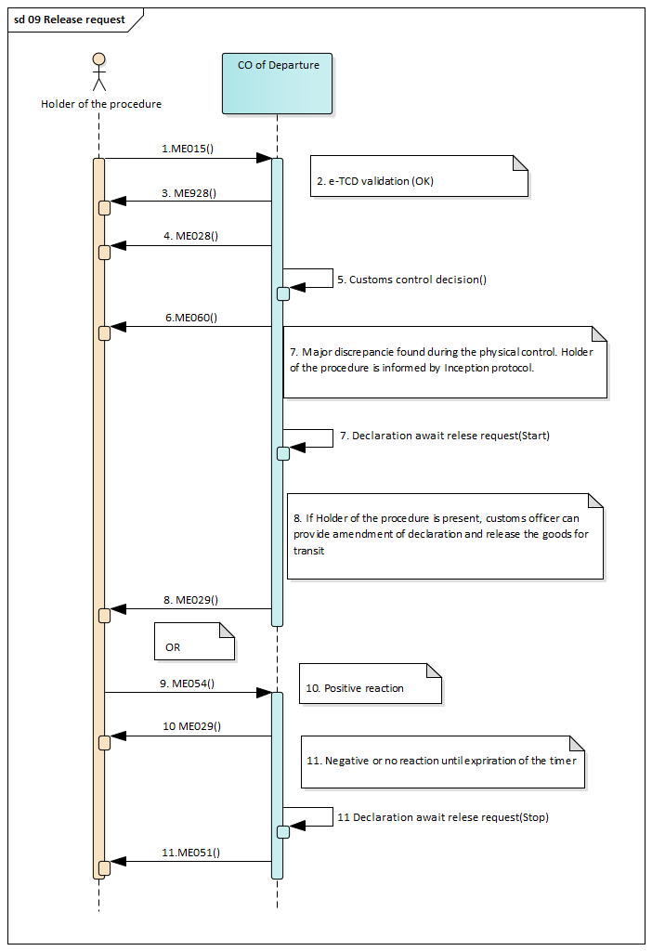
Figure 10 Release request

  - Guarantee not valid

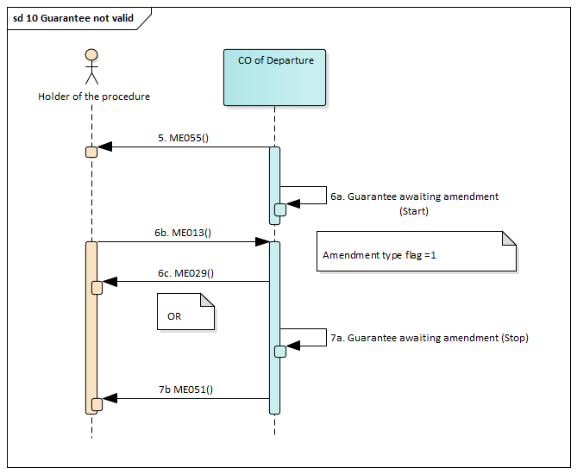
Figure 11 Guarantee not valid

This scenario is commonly used for standard and simplified procedure in transit regime. Scenario starts according to the description given in chapter 4.1 NCTS transit basic scenario, with point 1 and ending by point 4.

- During the validation of the guarantee there was a problem occurred. Office of Departure informs Holder of the procedure by the message ME055 about it .
- The timer “Guarantee awaiting amendment” is started. The Holder of the procedure can amend e-TCD within the timer by sending of ME013 message (Amendment type flag = 1) only data group “Guarantee”. After the new guarantee validation with positive result, declaration is automatically released (ME029).
- When the e-TCD is not amended within the timer, declaration is not released for transit regime (ME051).

  - Cancellation of the pre-lodged declaration prior to presentation of the goods or registered declaration before acceptation

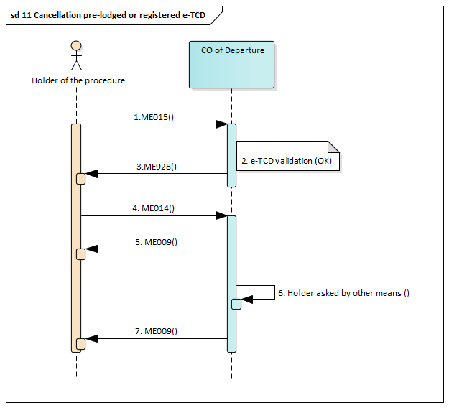
Figure 12 Cancellation of pre-lodged declaration before acceptation

This scenario is commonly used for standard and simplified procedure in transit regime. Scenario starts according to the description given in chapter 4.1 NCTS transit basic scenario, with point 1 and ending by point 3.

- The Holder of the transit procedure decides to cancel the pre-lodged or already registered
declaration by sending message ME014 to the Office of Departure.
- In case the ME014 message is valid, the Office of Departure automatically sends a positive
decision to cancel the registered declaration by the message ME009.
- The Holder of the procedure personally (by any other means) ask the customs officer to cancel
registered e- TCD.
- The Competent customs officer cancels the e-TCD (MRN) and fills in to the NTA_NCTSP5 the reason of cancelation (provided by Holder of the procedure or his representative). The NTA_NCTSP5 informs the Holder of the procedure via message ME009 that e-TCD is cancelled.
Competent customs officer can cancel registered e-TCD (MRN), only when Holder of the procedure presents another goods, different from the goods declared in e-TCD, or if the Holder of the procedure doesn’t present at the CO of Departure necessary documents accompanying e-TCD (e.g. transport documents, invoices, certificates, …). At the moment, when this cancelation of the registered e-TCD (MRN) is recorded in the NTA_NCTSP5, the message ND009 is sent to Holder of the procedure.

  - Invalidation of the declaration

An already accepted transit declaration (except when Office of Departure already decided about control) can be invalidated by the Holder of the Transit Procedure via ME014 message or manually when Holder of the procedure is presented at the Customs office (in written form or orally) before the goods are released for transit or can be revoked by customs officer on his own initiative. Transit declaration can be invalidated after release as well via ME014 message or on request sent by Holder of the procedure outside the system (in written form or orally).

    - Invalidation before release of the goods in standard and simplified procedure

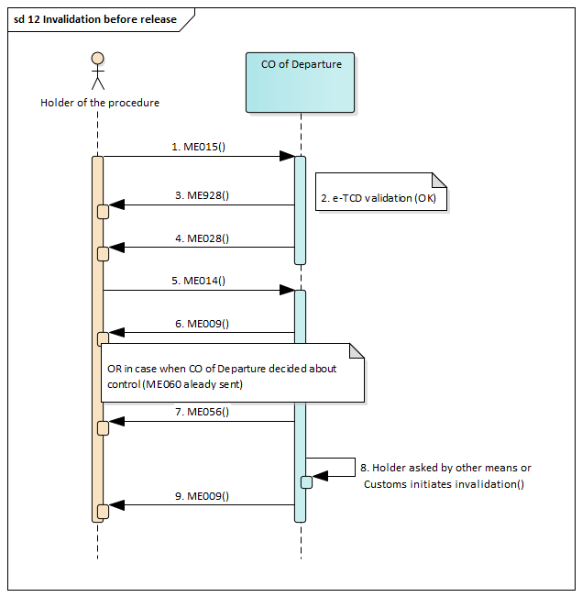
Figure 13 Invalidation before release

The e-TCD was accepted according steps described in chapter 4.1 NCTS transit basic scenario, standard procedure, in points from 1 to 4. The accepted e-TCD (MRN) could be cancelled at the request of Holder of the procedure (or his representative) at the CO of Departure in the case, when no customs controls have not been ordered.

- The Holder of the transit procedure decides to invalidate already registered declaration by sending
message ME014 to the Office of Departure.
- In case the ME014 message is valid, the CO of Departure automatically sends a positive
decision to invalidate the registered declaration by the message ME009.
- In case when Office of Departure already decided about control of the goods and informed by
ME060 message to Holder of the procedure, declaration can not be cancelled. NTA_NCTSP5
sends an error message ME056 with the error reason “Out of sequence”.
- The Holder of the procedure personally (by any other means) ask the customs officer to cancel
registered e- TCD after control of the goods.
- The Competent customs officer cancels the e-TCD (MRN) and fills in to the NTA_NCTSP5 the
reason of cancelation (provided by Holder of the procedure or his representative). The
NTA_NCTSP5 informs the Holder of the procedure via message ME009 that e-TCD is
cancelled.

Note:
In case of simplified procedure, cancellation is possible only during the time limit for automated release.
Customs officer can decide about invalidation from own initiative as well. In this case the message ME009 contains the data element “INVALIDATION/Initiated by customs = 1”.

    - Invalidation after release of the goods

The Holder of the Transit Procedure can request the CO of Departure to invalidate the transit declaration after the goods have been released for transit only in two specific cases:
  - Domestic goods have been declared in error for a transit procedure applicable only to foreing goods; or
  - Goods have been erroneously declared under more than one transit declaration.
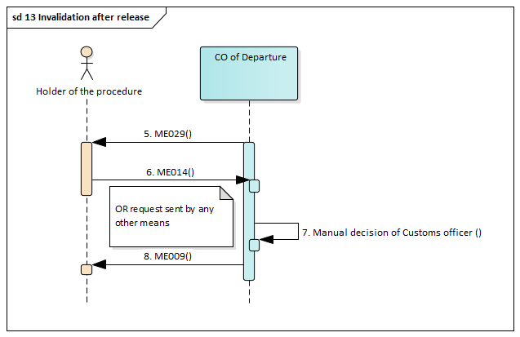
Figure 13 Invalidation after release

The e-TCD was accepted according steps described in chapter 4.1 NCTS transit basic scenario, standard procedure, in points from 1 to 5. The accepted e-TCD (MRN) could be cancelled at the request of Holder of the procedure (or his representative) at the CO of Departure in the case, when no customs controls have not been ordered.

- The Holder of the transit procedure decides to invalidate already released
declaration by sending message ME014 to the Office of Departure OR any other means.
- However, invalidation request received after release of the goods via the message ME014,
cannot be accepted automatically, but manually based on decision of customs officer.
- The Competent customs officer invalidates the e-TCD (MRN) and fills in to the NTA_NCTSP5
the reason of cancelation (provided by Holder of the procedure or his representative). The
NTA_NCTSP5 system informs the Holder of the procedure via message ME009 that e-TCD is
Invalidated.

Note:
Invalidation after release of the goods is manual process based on the decision of customs officer. It can be accepted or not accepted. The message ME009 can be positive ( INVALIDATION/Decision = 1 (yes) or negative (INVALIDATION/Decision = 0 (no)).

  - Solving of discrepancies at the Office of Departure

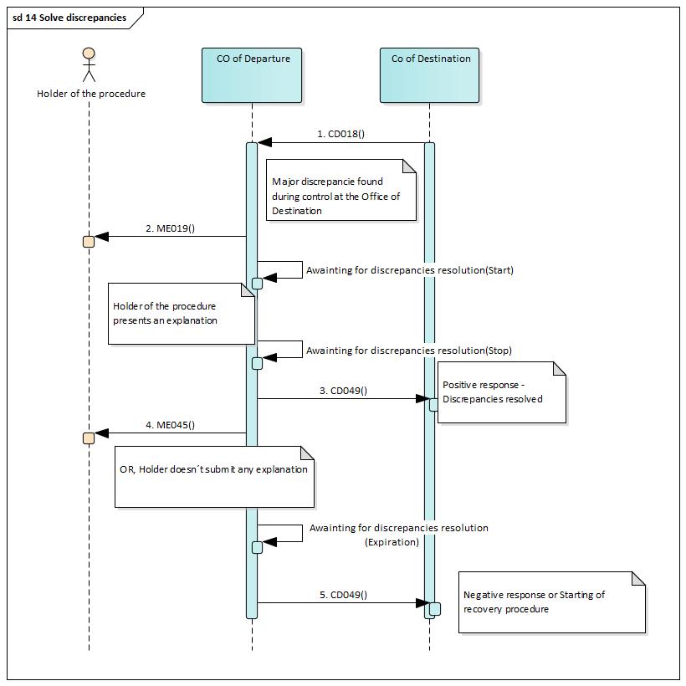
Figure 15 Soling of discrepancies at the CO of Departure

- When there are major discrepancies detected during the control of the goods at the Office of Destination.
- The Office of Departure notifies the Holder of the Transit Procedure of the fact that major discrepancies are reported in the destination control results with the message ME019. It should be noted that the sorting out and the resolution of the discrepancies is a paper-based procedure that is handled outside NTA_NCTSP5. The timer for discrepancies resolution (13 days) is started.
- The Office of Departure informs the Office of Destination by the message CD049 that these discrepancies were solved.
- When transit movement is discharged at the Office of Departure after solving of discrepancies, the Office of Departure informs Holder of the procedure by the message ME045.
- When discrepancies are not solved at Departure or timer for submit ion of explanation expiries, CO of Departure informs the Office of Destination by the message CD049 that these discrepancies were not solved and Recovery to be started.

  - Start of enquiry procedure
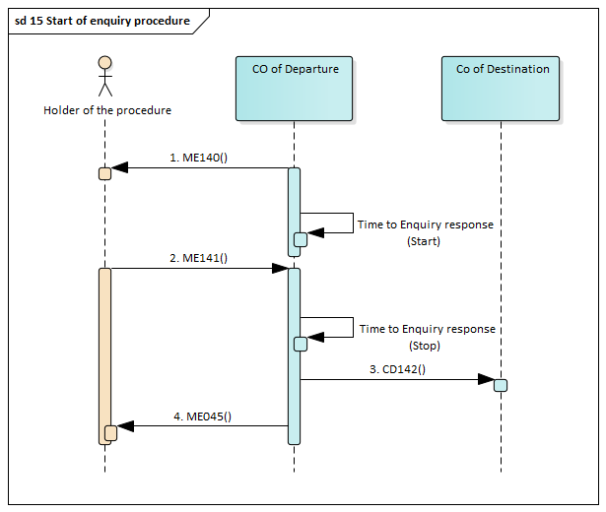
Figure 16 Start of enquiry procedure

The e-TCD was released to transit regime in standard procedure or in simplified procedure. The movement started, but the goods were not presented at CO of Destination in prescribed time, which was given for transportation/presentation of goods to the CO of Destination.

- Competent customs officer sends request for information related to enquiry procedure to Holder of the procedure by the message ME140. The timer for enquiry response (28 days) is started.
- The Holder of the procedure collects necessary documents and proofs about delayed movement (MRN) and prepares the enquiry response for the Office of Departure and sends the enquiry response in form of message ME141 to the CO of Departure within the time limit 28 days.

- The Office of Departure starts enquiry for the movement (MRN) at the customs office, which was declared or notified as an actual CO of Destination by Holder of the procedure.

- The enquiry procedure could be finished by proving that the transit regime was successfully ended at the Office of Destination, or by recovering of customs debt incurred in transit regime. In both cases, Holder of the procedure is informed via message ME045, that all procedures related to this movement (MRN) were finished.

  - Start of recovery procedure
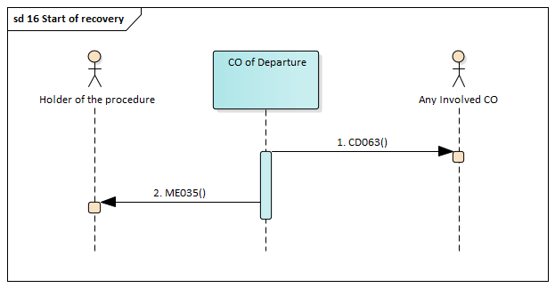
Figure 17 Start of recovery procedure

- When enquiry procedure was not successful or Holder of the procedure did provide no information or no sufficient information, the competent customs officer at the CO of Departure decided about start of recovery procedure. CO of Departure informs all customs offices involved in the movement (CODestination, COTransit, COExit for Transit) by the message by the message CD063 – Recovery communication.
- Holder of the procedure is informed by CO of Departure by the message ME035. Recovery is started as paper procedure.

  - Incident en route registration

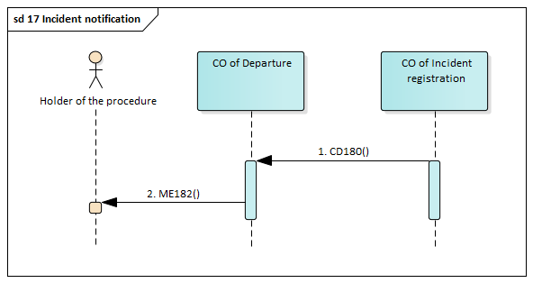
Figure 17 Incident en route

- Even in case the Office of Incident Registration is involved into the transit movement the CO of Incident Registration sends information to CO of Departure via the message CD180 – Incident notification.
- Upon reception of the message CD180, the Office of Departure forwards the incident information to the Holder of the Transit Procedure through the ME182 message.

- Communication between Consignee and the Customs office of Destination

The Customs office of Destination is a customs office where goods placed under the transit procedure (national transit or common transit) must be presented in order to end the transit procedure.

The presentation of the goods can be notified to the CO of Destination manually using the TAD or at least MRN or electronically using message ME007 sent to the CO of Destination. When simplified procedure is used, Authorised Consignee is obliged to notify the presentation of goods electronically, using message ME007 sent to the CO of Destination.
Authorisation for electronic communication with Offices of Destination is necessary for EDI (electronic massage exchange) between the Consignee and the CO of Destination.
The authorisation of the Authorised Consignee shall be issued for use of simplified procedure of Authorised Consignee at the CO of Destination.

  - Standard procedure at the CO of Destination- basic scenario
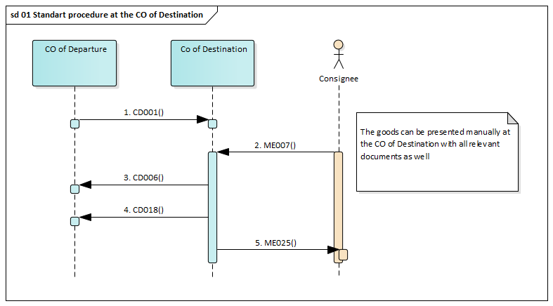
Figure 18 Standard procedure at the CO of Destination

The Consignee, who is not a holder of the authorisation for use of simplified procedure of Authorised Consignee, must present the consignment (the goods released for transit regime) physically at the CO of Destination in prescribed time-limit and within the customs office working hours.

- The NTA_NCTSP5 at the CO of Departure informs declared CO of Destination about the movement via message CD001. This message contains data about the goods, which were released to transit regime.

- In standard procedure, the goods must be presented directly at the CO of Destination. The consignment (goods released for transit regime) could be presented and notified using paper form of TAD (Transit Accompanying Document and List of Items or at least MRN) or electronically by sending the message ME007 to the CO of Destination. The electronic notification of presentation of goods can speed up the procedure at the CO of Destination.

- The NTA_NCTSP5 at the CO of Destination informs the CO of Departure, that the goods (consignment) were delivered to destination via message CD006.

- When the consignment (goods released for transit regime) is presented at the CO of Destination, the competent customs officer removes the seal(s) and controls presented goods and accompanying documents using the e-TCD data from the message CD001. The competent customs officer shall input the customs control results into NTA_NCTSP5 system and decide to end the transit regime. The NTA_NCTSP5 at the CO of Destination informs the CO of Departure, that the transit regime was ended at the CO of Destination via message CD018, which contains the result of customs control.

- The NTA_NCTSP5 informs the consignee (if he has the Authorisation for electronic communication with Customs Offices of Destination) via message ME025, that the transit regime was ended and that the transited goods have the status of temporary storage. The Consignee is obliged to submit the summary declaration(s) to cover these goods in temporary storage or to lodge the customs declaration(s) for placing the goods for customs regime in given time-limit.

  - Simplified procedure at the CO of Destination – basic scenario

The Consignee, who would like to use the simplified procedure of the Authorised Consignee, must be a holder of the Authorisation for use of simplified procedure of Authorised Consignee.

The Authorised Consignee can end the transit in days and hours given by the CO of Destination (ie. 24 hours per day and 7 day per week) at his premises or other places, which are authorised by the CO of Destination.
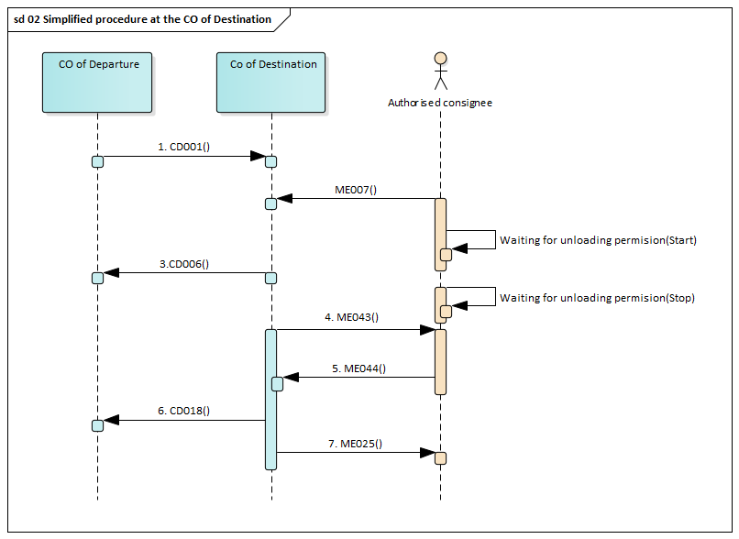
Figure 19 Simplified procedure at the CO of Destination

- The NTA_NCTSP5 at the CO of Departure informs declared CO of Destination about the movement via message C_ARR_SND (CD001). This message contains data about the goods, which were released to transit regime.

- In simplified procedure, the goods are presented at authorized place in premises of the Authorized Consignee. The arrival is notified by the Authorized Consignee to the CO of Destination electronically via sending the message ME007. The Authorised Consignee is obliged to wait for taking the decision on possible customs control or for the unloading permission. Till the moment, when unloading is permitted, the consignment must remain under the custom seal(s) at authorized place.

- The NTA_NCTSP5 at the CO of Destination informs the CO of Departure, that the goods (consignment) were delivered to destination via message CD006.

- In the case, when no customs control is ordered, the NTA_NCTSP5 sends the message ME043 to Authorised Consignee. The time limit for taking the decision on possible customs control is specified individually in the Authorisation of Authorised Consignee.
At the moment, when Authorised Consignee receives the message ME043, the unloading of goods can start and the customs seal(s) could be removed. The unloading permission message, ME043, contains the valid data of the e-TCD.
The Authorised Consignee is obliged to unload the goods and to check the goods against the data, which were received from the CO of Departure using the message ME043. Each discrepancy shall be pointed out by the Authorised Consignee.
The printed Transit Accompanying Document (TAD) and List of Items (LoI), in case there were presented to the Authorised Consignee by the carrier (e.g. track driver), have no importance for process of the unloading and shall not be used for control of goods by the Authorised Consignee. The Trader’s SW – NCTS application must support the print out the TAD and LoI from the on data received in message ME043 as a kind of support for control of goods by the Authorised Consignee.
The results of controls are collected and entered into the NTA_NCTSP5 application used by the Authorised Consignee after the unloading of goods is finished. If any irregularities are found, the Authorised Consignee is obliged to contact the CO of Destination according to rules given in his authorisation for use of simplified procedure.
In the event that any incidents have occurred, the Authorised consignee has to register them in the control results – ME044 message.

- Authorised Consignee sends to the CO of Destination the message with unloading remarks ME044.

- The NTA_NCTSP5 at the CO of Destination checks the results of controls. If the unloading is completed and there are no discrepancies, the transit regime is ended and it is recorded by the NTA_NCTSP5 system at the CO of Destination. The NTA_NCTSP5 at the CO of Destination informs the CO of Departure, that the transit regime was ended at destination via message CD018, which contains the result of customs control.

- The NTA_NCTSP5 informs the Authorised Consignee via message ME025, that the transit regime was ended and that the transited goods have the status of temporary storage. The Authorised Consignee is obliged to submit the summary declaration(s) to cover these goods in temporary storage or to lodge the customs declaration(s) for placing the goods for customs regime in given time-limit.

- Authorised Consignee completes the Transit Accompanying Document (TAD) and List of Items (LoI) and other documents if where accompanying this consignment and follows the instructions specified in certification for simplified procedure.

Filling of ME007 message in simplified procedure at Destination – Authorised consignee
  - AUTHORISATION/Decision reference number is used with “Authorisation type = C522 or C520”
C520 – ACT – Authorisation for the status of authorised consignee for national TIR procedure
C522 – ACE – Authorisation for the status of authorised consignee for common transit

  - CONSIGMENT/LOCATION OF GOODS data group will be used
    - Type of location – B– Authorised place
    - Qualifier of identification – Y – Authorisation number
    - Authorisation number – real reference number of authorization location of goods
    - Additional identifier – can be used for identification of location where there are several locations associated with one authorization

    - Minor discrepancies during unloading

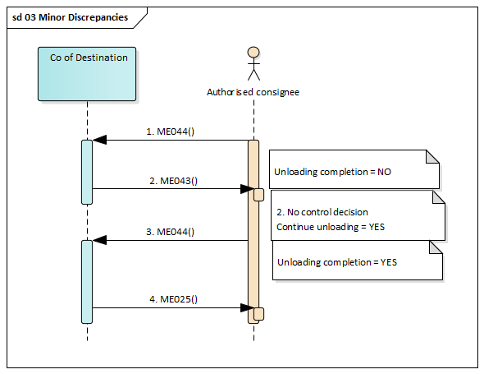
Figure 20 Minor discrepancies at the CO of Destination

- When there a minor discrepancies (missing goods, unexpected goods) are found during the unloading of goods, the Authorised Consignee is obliged to interrupt the unloading and ask the CO of Destination for intervention (flag “Unloading remark/ Unloading completion”=”No” in the message ME044 and further instructions.
- When the Customs Officer decides not to control and the unloading is not completed, NTA_NCTSP5 records this decision and notifies (ME043 with “CTL Control/Continue unloading= 1”) the Authorised Consignee of the decision allowing him to continue the unloading. Otherwise. Simplified procedure is interrupted, physical control of the goods will be carried out by customs officer and final control results will be registered by CO of Destination.
- Upon completion of unloading the Authorised consignee shall send the final control results. lag “Unloading remark/ Unloading completion”=”Yes” in the message ME044.
- The NTA_NCTSP5 informs the Authorised Consignee via message ME025, that the transit regime was ended and that the transited goods have the status of temporary storage. The Authorised Consignee is obliged to submit the summary declaration(s) to cover these goods in temporary storage or to lodge the customs declaration(s) for placing the goods for customs regime in given time-limit.

    - Major discrepancies

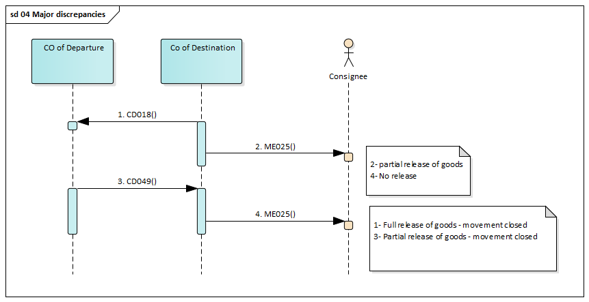
Figure 21 Major discrepancies at the CO of Destination

- In case of major discrepancies detected during control the ‘Destination Control Results’ CD018 will be sent to Office of Departure.
- The CO of Destination will send the message ME025 to the Authorised consignee in order to notify him that the transit procedure has not ended yet at the CO of Destination due to the existence of major discrepancies in the destination’s control results having the data element “CONSIGNMENT/HOUSE CONSIGNMENT/CONSIGNMENT ITEM/Release type ” flag equal to “2-Partial released of goods” or “4-No release”. , and the status will be set to “Waiting for discrepancies resolution”.
- This state will change after reception of the ‘Write-off Notification’ (CD049) from the CO of Departure that indicates that the discrepancies have been resolved or recovery will start at the CO of Departure.
- Additionally, a notification is sent that goods are released (ME025 message) is sent to the Authorised consignee having the release decision value equal to 1- Full release of goods (as per declaration) – Movement closed” or “3- Partial release of goods – Movement closed”]. The status will become “Goods released”.

  - Customs control at the CO of Destination

The customs control at the CO of Destination is a legally supported by Montenegrin customs legislation. In the case, when the customs control is ordered, the use of simplified procedure Authorised Consignee is interrupted and the customs control is performed by customs authorities.

Standard procedure

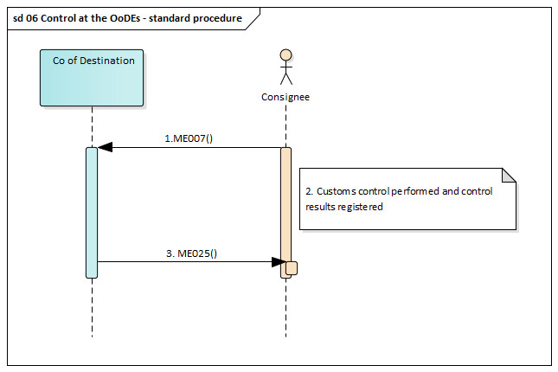
Figure 22 Control of the goods at the CO of Destination- standard procedure

- The goods were presented and notified electronically by the Consignee using the message ME007 at the CO of Destination,
- Control of the goods and all relevant documents is performed, control results are registered in the NTA_NCTSP5 at CO of Destination,
- The NTA_NCTSP5 informs the consignee (if he has the Authorisation for electronic communication with Customs Offices of Destination) via message ME025, that the transit regime was ended and that the transited goods have the status of temporary storage. The Consignee is obliged to submit the summary declaration(s) to cover these goods in temporary storage or to lodge the customs declaration(s) for placing the goods for customs regime in given time-limit.

If the transited goods were presented at the CO of Destination with the Transit Accompanying Document (TAD) and List of Items (LoI) and without the electronic notification, no message ME060 could be sent to the Consignee. The Consignee is present at the CO of Destination, or the Consignee must be informed by his Representative

Simplified procedure

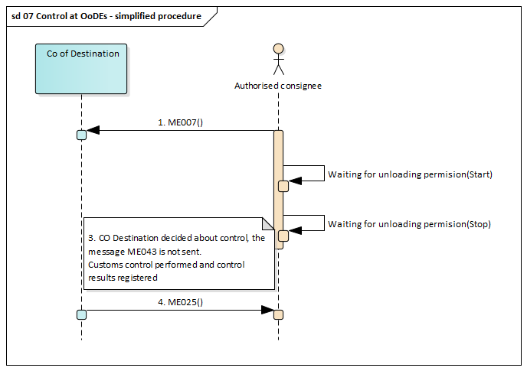
Figure 23 Control of the goods at the CO of Destination- simplified procedure

- The Authorised Consignee notifies the arrival of the transit movement (goods released for transit procedure) at destination to the CO of Destination electronically via the message
ME007. The Authorised Consignee is obliged to wait for taking the decision on possible customs control or for sending the unloading permission. The timer for automated unloading permission is started.

- At the moment, when the CO of Destination decided about control of the goods , the Authorised Consignee doesn’t receive the message ME043. Authorised Consignee shall not remove the seal(s) and he must wait for customs control (inspection). The use of simplified procedure authorised consignee is stopped, the customs control is performed and this transit regime (MRN) will be ended by the CO of Destination in standard procedure.

- CO of Destination performs control of the goods and register control results.

- The NTA_NCTSP5 informs the Authorised Consignee via message ME025, that the transit regime (MRN) was ended and that transited goods have the status of temporary storage. The Authorised Consignee is obliged to submit the summary declaration(s) to cover these goods in temporary storage or to lodge the customs declaration(s) for placing the goods for customs regime in given time-limit.

  - Diversion rejected at the Office of Destination

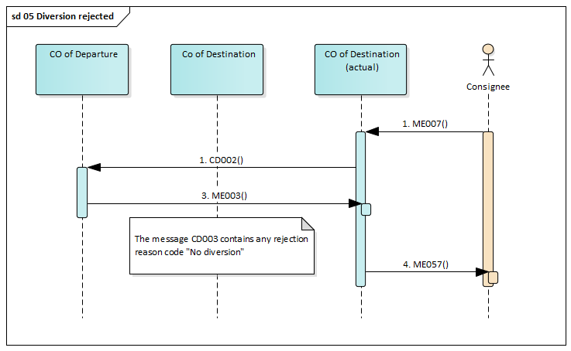
Figure 24 Diversion rejection at the CO of Destination

The goods placed in transit regime which are presented at the actual CO of Destination (not declared) or which are presented at the premises of the Authorised Consignor, cannot be refused in any regular case. But, considering human or technical mistakes, there could appear following cases when the ending of transit regime is refused:
- MRN presented in ME007 message by authorized consignee is not existing or not released for transit,
- In case of prescribed “Binding itinerary”, CO of Departure rejected diversion,
- Other reasons e.g. transit movement (MRN) already presented at another CO of Destination or invalidated.

In these cases, the notification of goods presentation, which was done in electronic form via message ME007, could be refused by the CO of Destination by message ME057.
In standard procedure, when the consignment is presented at the CO of Destination, the competent customs officer starts the necessary procedure to solve these irregular circumstances. The movement is ended using the fall-back procedure.
If the simplified procedure of authorised consignee is used, the Authorised Consignee:
- does not received the unloading permission (ME043 message),
- may not remove the seals
- must contact the CO of Destination
- must wait for solution of CO of Destination
The ending of the transit regimes is done in the fall-back procedure by the CO of Destination at its premises or at the Consignee’s premises. Each case is solved individually according the particular conditions.
- General data Exchange
Each exchanged message specifies names of elements, their formats, number of occurrences and other rules and restrictions, which have to be fulfilled, so that the message can be accepted. First step or processing of incoming message in central system of the MCA is to check all rules and restrictions, i.e. check against XSD schema, check against code lists and check appropriate rules/conditions. If any error occurs, then processing is stopped and the ME056 message is sent back from CO of Departure to the Holder of the procedure or his Representative or the ME057 message is sent back from CO of Destination to the Consignee / Authorised consignee or his Representative where all detected errors are included.
  - Functional error at the CO of Departure
If the validation of the received message at the CO of Departure is unsuccessful, NTA_NCTSP5 send an error message ME056.
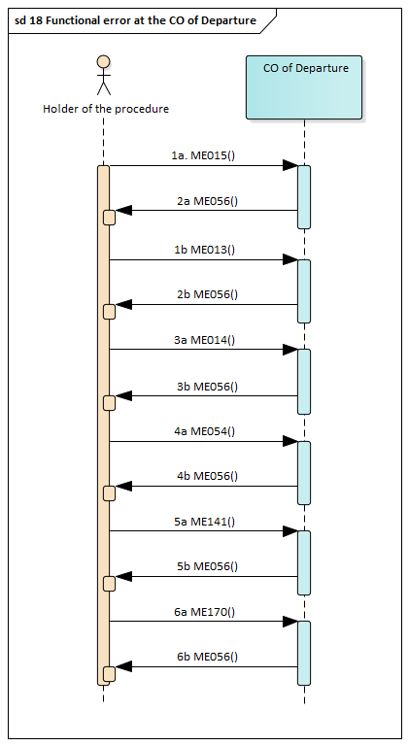
Figure 25 Functional error at the CO of Departure

  - Functional error at the CO of Destination
If the validation of the received message at the CO of Destination is unsuccessful, NTA_NCTSP5 send an error message ME057.

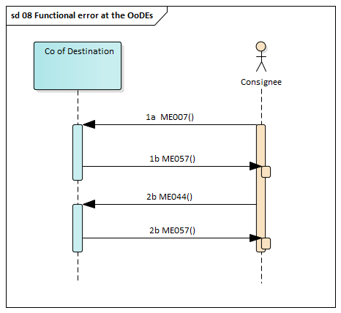
Figure 26 Functional error at the CO of Destination

  - Technical XML error

When where used some wrong XML data elements (XML structure is wrong), the message ME917 is sent by CO of Departure / CO of Destination to the Holder of the procedure or consignee.

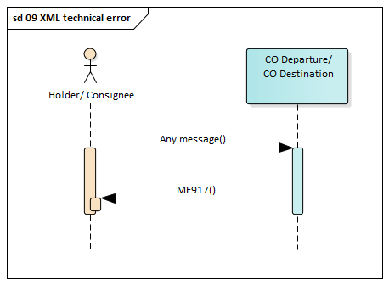

- Structure of messages
This chapter introduces the structures of all the electronic messages used. The structures, together with the roles and conditions, have been created and will be updated as necessary using the html page:
https://podpora.aquasoft.eu/portal/Pages/Account/LoginPage.aspx?ReturnUrl=%2fportal%2fPages%2fRecords%2fAllRecordsPage.aspx

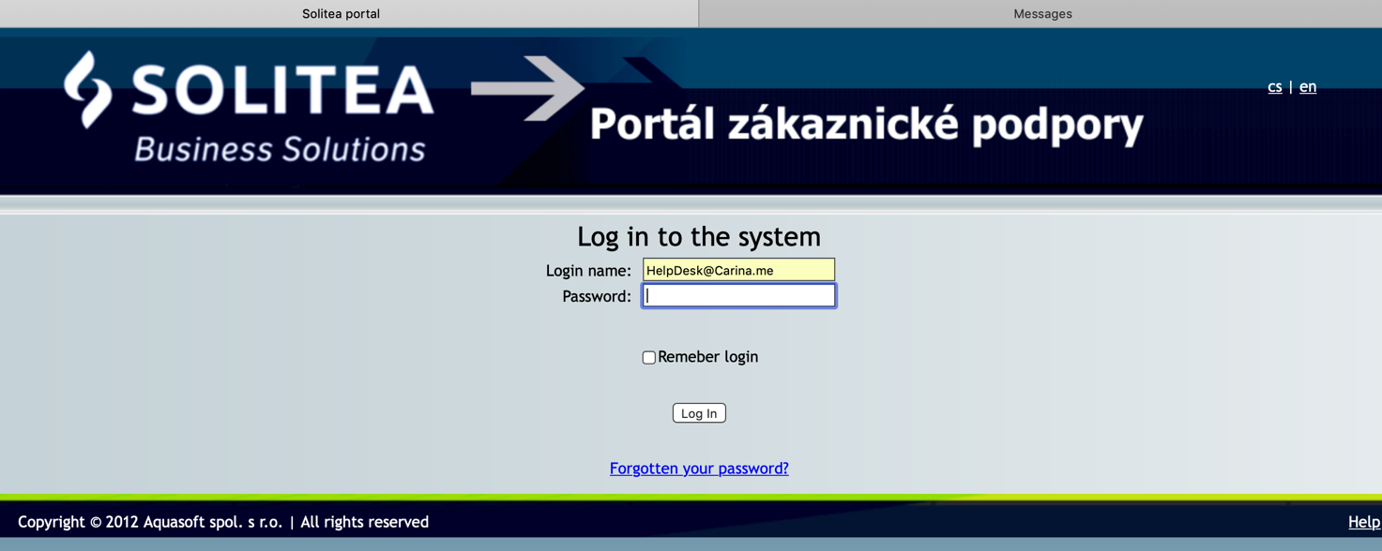

Login name: HelpDesk@Carina.me
Password: HelpDesk

The link for publication at the official web site of Montenegrin Custom Administration must be created by MCA.

- The list of annexes
Annex 1 – The structure of messages including conditions and roles (XLS)
Annex 2 - The structure of messages including conditions and roles (html)
Annex 3 – XSD schemas
Annex 4 – Translation of conditions and roles

